ve

**TRC User Manual v 1.0**

* **Central Equipment Identity Register Portal**

Document Change History

|  |  |  |  |
| --- | --- | --- | --- |
| Version | Change Type | Description | Date |
| Draft |  | Submitted for internal review | March 2020 |
| Version 2.0 |  | Update done for feedback received during AT & Key changes | May 2021 |

Contents

Document Change History i

Contents ii

Figures iii

1 Overview 1

1.1 Scope 1

1.2 Acronyms & Abbreviations 1

1.3 Conventions 1

2 TRC Operations 2

2.1 Application Overview 2

2.2 Logging into the Application 2

2.3 Application User Interface 8

2.3.1 Dashboard 11

2.4 Manage Type Approval 14

2.5 Edit Type Approved Devices 19

2.6 Filter Type Approval Requests 21

2.7 Sorting Type Approved Requests 22

2.8 Export Type Approved Requests 22

2.9 Grievance Management 24

2.10 Filter Grievances 28

2.11 Sorting Grievances 29

2.12 Export Grievances 30

Figures

Figure 1: CEIR Home Page 2

Figure 2: TRC Registration 3

Figure 3: Verify OTP 5

Figure 4: Enter OTP 5

Figure 5: Login 6

Figure 6: Home Page 7

Figure 7: Forgot Password 7

Figure 8: Set New Password 8

Figure 9: Home Page 8

Figure 10: Edit Information 10

Figure 11: Change Password 10

Figure 12: Manage Account 11

Figure 13: Home Page 11

Figure 14: Grievance Management 12

Figure 15: Manage Type-Approved 13

Figure 16: Notifications 13

Figure 17: Home Page 15

Figure 18: Manage Type-Approved 16

Figure 19: Type-Approved Devices 16

Figure 20: Manage Type-Approved 17

Figure 21: Manage Type-Approved 20

Figure 22: Update Report Type-Approve Devices 20

Figure 23: Filter Type Approval Requests 21

Figure 25: Export Type Approval Requests 23

Figure 26: Open or Save Exported File 23

Figure 27: Exported Type Approval Requests 23

Figure 28: Home Page 24

Figure 29: Grievance Management 25

Figure 30: Create Grievance 25

Figure 31: Grievance Management 27

Figure 32: Filter Grievances 28

Figure 33: Filtered Grievances 29

Figure 34: Grievance Management 30

Figure 35: Open or Save Exported Grievance File 31

Figure 36: Exported Grievances 31

# Overview

## Scope

The objective of this manual is to help TRC use the CEIR (Central Equipment Identity Register) application to report Type approved devices and report grievances.

## Acronyms & Abbreviations

| **Acronym** | **Full Form** |
| --- | --- |
| CEIR | Central Equipment Identity Register |
| IMEI | International Mobile Equipment Identity |
| PDA | Personal Digital Assistant |
| TAC | Type Allocation Code |
| TRC | Telecommunication Regulator of Cambodia |

## Conventions

| **Information** | **Convention** |
| --- | --- |
| UI elements  (such as names of windows, buttons, and fields) | Bold |
| References  (such as names of files, sections, paths, and  parameters) | *Italics* |
| **\*** | Indicates a mandatory field or column |

# TRC Operations

## Application Overview

The CEIR (Central Equipment Identity Register) TRC Portal application is used to report type approved SIM-based devices that are imported in Cambodia. Registration of TAC of all the imported devices ensures that legal devices are made available for sale in the market.

TRC perform the following tasks:

* Report type approval certificates for the imported devices

Report grievances

## Logging into the Application

Before login, the TRC must register in the application.

To register:

1. Enter the CEIR Home Portal URL in the browser address bar. This opens the CEIR Home Portal page.

Figure 1: CEIR Home Page

1. Select **TRC** form the **Registration** list.

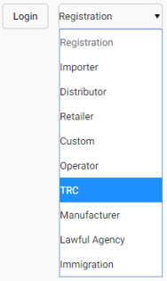

The **TRC Registration** page appears. The TRC needs to fill in the following information.

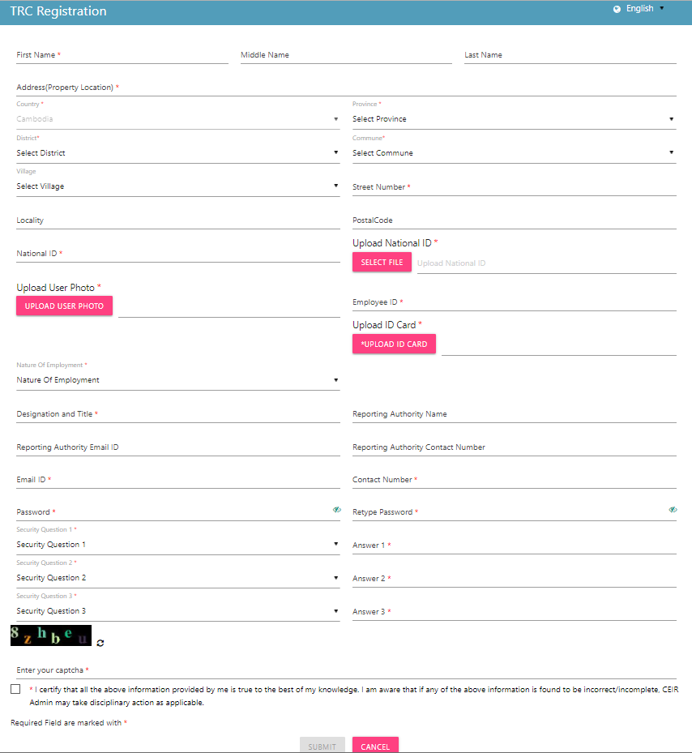

Figure 2: TRC Registration

1. **\*First Name**: Enter the first name.
2. **Middle Name**: Enter the middle name (if any).
3. **\*Last Name**: Enter the last name.
4. **\*Email**: Enter the mail ID. This mail ID would be used for communication.
5. **\*Phone**: Enter the contact number. This number would be used to send notifications.
6. **\*Address**: Enter the TRC ’s address:
   1. Street Number
   2. Village
   3. Locality
   4. District
   5. Commune
   6. Province
   7. Country
7. **\*National ID**: Enter national ID.
8. **\*Upload National ID:** Upload National ID file
9. **\*Upload Photo:** Upload Photo file
10. **\*Employee ID:** Enter employee ID.
11. **\*Upload ID Card:** Upload Official ID Card file
12. **\*Nature of Employment:** Select nature of Employment.
13. **\*Designation and Title:** Enter designation/Title of Reporting Authority in your organization.
14. **\*Reporting Authority Name:** Enter name of Reporting Authority in your organization.
15. **\*Reporting Authority Email ID:** Enter e-mail ID of Reporting Authority in your organization.
16. **\*Reporting Authority Contact Number:** Enter contact number of Reporting Authority in your organization.
17. **\*Password**: Enter a login password. This is the password that would be used to log into the CEIR TRC Portal application.
18. **\*Confirm Password**: Re-enter the password for confirmation.
19. **\***Select three security questions and enter an answer for each question. This is required by the system when the TRC forgets the password. In such a situation, the system requires identification to authenticate the TRC. These security questions are used for authentication of the TRC.
20. **\***Enter the captcha shown on the page. This is required to prove that the TRC is not a robot.
21. **\***Select the declaration check box.
22. Click **SUBMIT**.

An OTP is sent to the TRC personnel’s mail ID and contact number.

Figure 3: Verify OTP

The TRC personnel is prompted to enter both the OTPs in the page for verification.

Figure 4: Enter OTP

Enter the two OTPs and click **Done**.

If the two OTPs match, the following message appears. If the OTPs do not match, click **Resend OTP**. The two OTPs are resent, one to the contact number and the other to the mail account.

After the OTPs are verified successfully, the registration request is sent to the CEIR Admin. The approval turnaround time is 2-3 days. After approval from the CEIR Admin, a mail containing the TRC’s registration ID is sent to the TRC ’s mail account. This registration ID is a unique automatically generated ID. This ID is the login username for access to the CEIR TRC Portal application.

To start using the application, log into the application.

To login:

1. Open the browser and enter the CEIR TRC Portal URL in the address bar. The login screen appears.

Figure 5: Login

On the top right corner of the login screen is the **Language** option. The application supports two languages: **English** and **Khmer**. On selecting a given language, all the field and column labels in the application appear in the selected language. All user inputs are, however, in English.

1. Next, enter the assigned login username and password.

Username is the registration ID that is sent on mail to the TRC after successful registration in the system. The registration ID is a unique ID that is automatically generated by the system. The login password is the password that the TRC enters in the registration page. Refer to during *Figure 2: TRC Registration*.

1. Enter the captcha.
2. Click **LOGIN**.

If the login and password are incorrect or the captcha is not correct, an error message appears, and you are prompted to re-enter the login details.

On entering correct information, the application Home page appears.

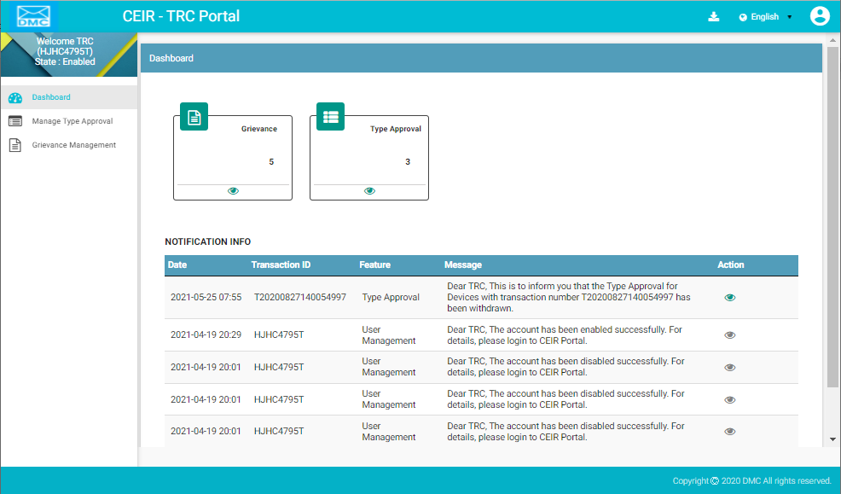

Figure 6: Home Page

If the TRC forgets the assigned password, click the **Forgot Password** link on the **Login** page. The **Forgot Password** page appears.

Figure 7: Forgot Password

1. Enter the login username.
2. Select a security question from the list. Select any one of the security questions that were selected during registration.
3. Enter the answer to the selected security question. This should match the answer given at the time of registration.
4. Click **SUBMIT**.

The **Set New Password** page appears.

Figure 8: Set New Password

1. Enter a new password. Click  to see the password characters being entered. Click on it again to hide the password characters. This works like a toggle key.
2. Re-enter the password.
3. Click **Save**.

## Application User Interface

On logging into the application successfully, the CEIR TRC Portal Home page appears.



Figure 9: Home Page

The Home page has all the feature menus on the left panel.

The center of the page is the Dashboard.

The top right corner of the screen displays the following menu options:

* **Download**: Click to download this user manual.
* **English**: Select **English** or **Khmer**. All the field and column labels appear in the selected language. User inputs are, however, in English.

* **Home**: Click on it to go to the **DMC Home Portal** page.
* A close up of a logo

  Description automatically generated(**User profile**): Click on it to see the following menu:

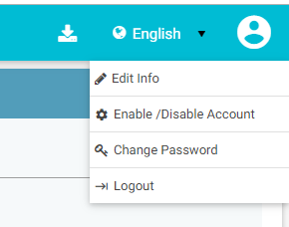73464221

*  (**Edit Info**): Click on it to modify the registered information. The **Edit Information** page opens.

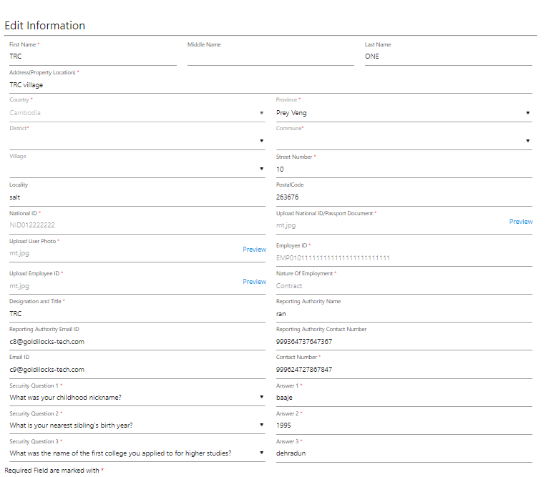

Figure 10: Edit Information

1. Make the required changes.
2. Click **Submit** to save the changes.

*  (**Change Password**): Click on it change the login password.

Figure 11: Change Password

1. **Old Password**: Enter the existing password. Click  to see the password characters being entered. Click on it again to hide the password characters. This works like a toggle key.
2. **New Password**: Enter a new password.
3. **Confirm Password**: Re-enter the new password to confirm the password.
4. Click **SUBMIT**.

*  (**Enable/Disable Account**): TRC s can deactivate their account or disable/enable their account.
  + Deactivating an account means deleting the TRC ’s account. Once the TRC ’s account is deleted, the TRC can raise a grievance to reactivate it when required. The grievance is sent to the CEIR Admin who reactivates the account. After reactivation, the TRC can use the same login username and password to log into the application.
  + When the account is disabled, TRC s can only view information and not add or modify information in the application. After the account is disabled, the TRC can enable it using the same menu.

Figure 12: Manage Account

1. Select **Deactivate** or **Disable**.
2. Click **SUBMIT**.

### Dashboard

The Dashboard provides a quick display and access to the following information:

* Type Approved Requests
* Grievances

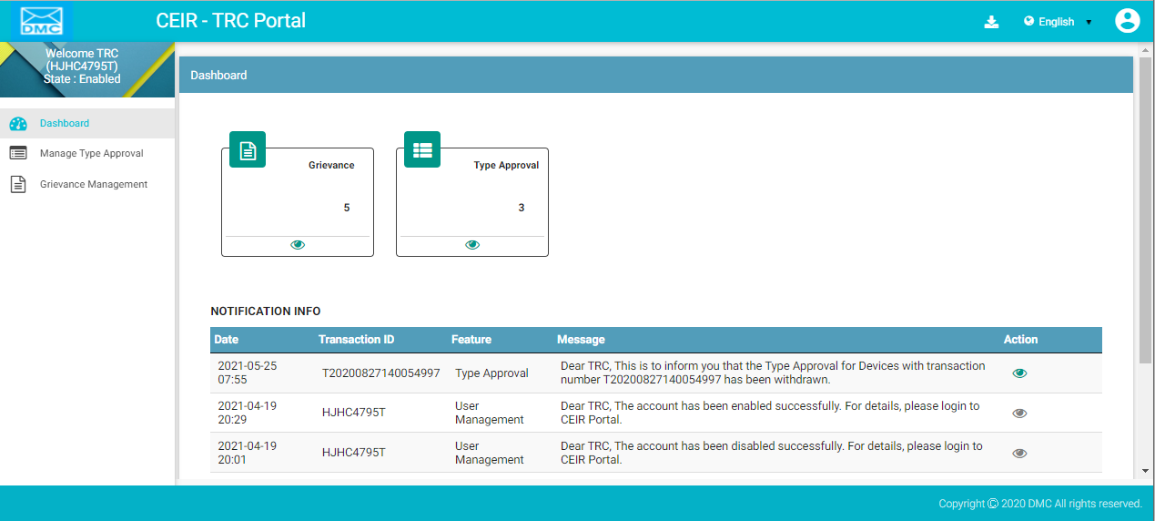

Figure 13: Home Page

**Grievances**

The box displays the total number of grievances that are open.

Click  **(View)** to access the **Grievance Management** dashboard. Refer to *Grievance Management* for more information.

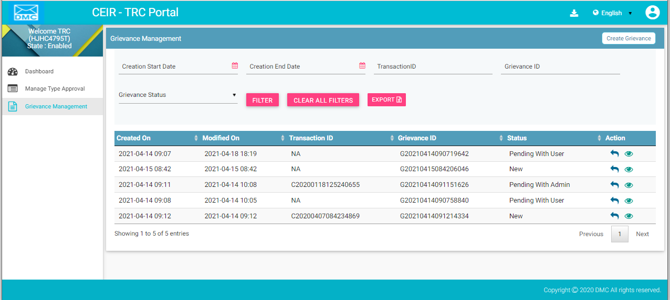

Figure 14: Grievance Management

**Type Approved**

The box displays the total number of type approval requests that are pending for approval.

Click  (**View**) to access the **Manage Type-Approved** dashboard. Refer to *Type Approval Management* for more information.

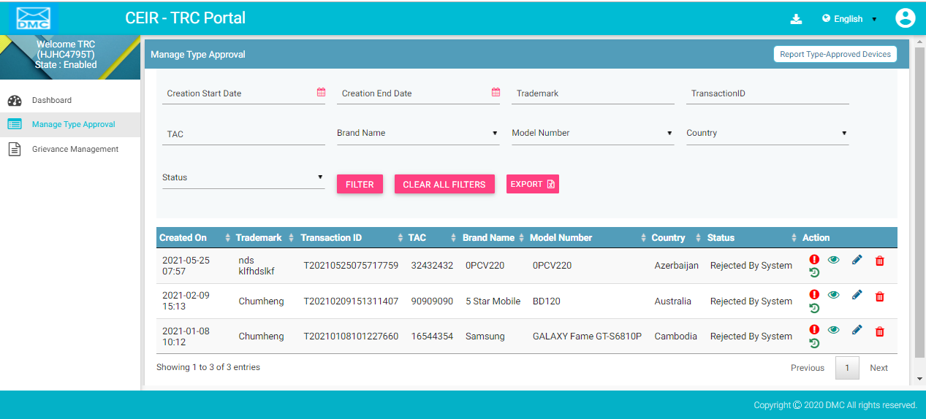

Figure 15: Manage Type-Approved

**Notification Information**

This section displays the most recent notifications. The System Admin can configure the total number of notifications displayed on users screens.

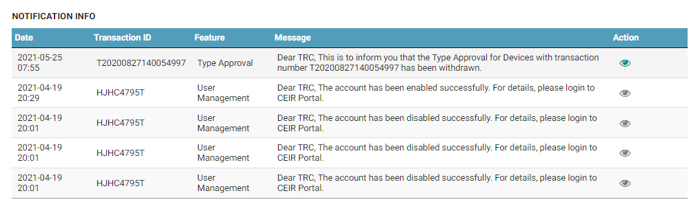

Figure 16: Notifications

Notifications are of two types.

1. Notifications that provide only information. For example, a notification informing the TRC about the account status is an information only notification because it requires no action. The **View** icon () is disabled in such notifications.



1. Notifications that require some action by the TRC. For example, a notification about the type approval request approval or rejection by the CEIR Admin requires the TRC to take some action such as fix the errors in the type approval request. The **View** icon () is enabled in such notifications. Click  (**View)** to access the relevant page of the notification.



The notification panel has the following columns:

* **Date**: Date of sending the notification
* **Transaction ID**: Transaction ID of the type approval request for which the notification is sent. If the notification is related to the TRC account, the login username is shown instead of any transaction ID.
* **Feature**: This is the name of the feature for which the notification is sent. For example, if the notification is for a type approval request, the feature name **Type Approval** is shown. The feature name is the one shown in the left panel of the Home page.
* **Message**: This is the message of the notification. An example is shown below.



* **Action**: This shows the **View** icon. It is activated  if the TRC can click on it else it is disabled .





## Manage Type Approval

TRC issues a TAC (Type Allocation Code) approval certificate to the importer in response to their request to seek permission to import certain type of devices from the TRC (Telecommunication Regulator of Cambodia) when purchasing a consignment. The TAC approval certificate is required for each unique TAC.

* TAC refers to the first eight alphanumeric characters of the device IMEI.

Consider a situation in which a TRC is approving a request that has Apple mobile devices: i10 and i9. There would be two TAC approval certificates required, one for the i10s and the other for i9s.

The TAC approval certificate is required for clearance at customs.

The type approval request goes through the following review stages:

* TRC uploads the request details.
* The request is processed and made available to the CEIR Admin.
* The CEIR Admin may approve or reject the request.
* If rejected, the TRC can withdraw the request. The entire cycle is then repeated until it is approved.

To upload type approved device details:

1. Select **Manage Type Approval** in the left panel.

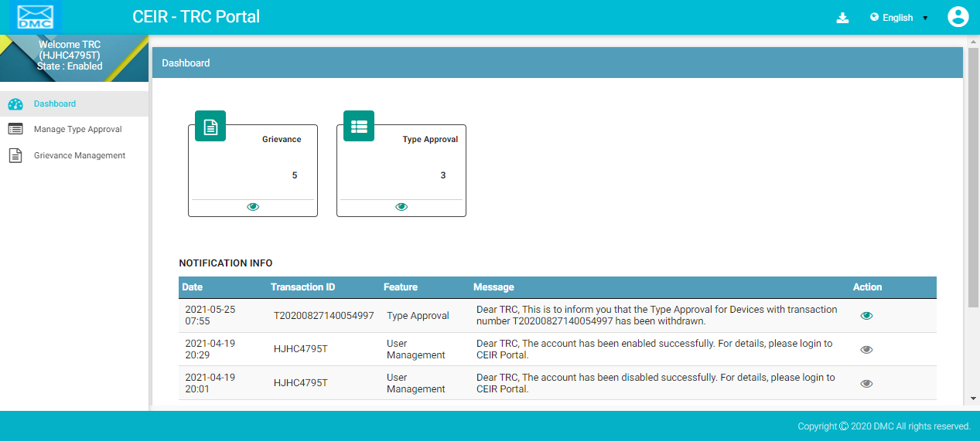

Figure 17: Home Page

The **Manage Type-Approved** dashboard appears.

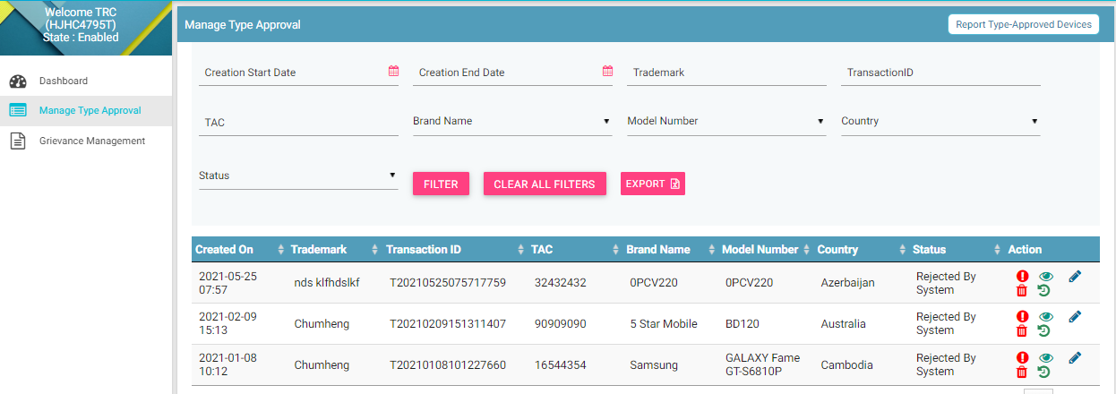

Figure 18: Manage Type-Approved

1. Click **Report Type-Approved Devices** (seen on the top right corner of the page). The **Type-Approved Devices** page appears.

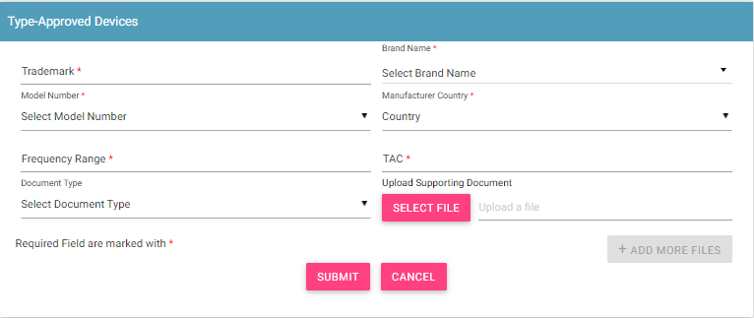

Figure 19: Type-Approved Devices

1. Enter the following information:
   1. **\*Trademark**: Enter the trademark of the product.
   2. **\*Product Name**: Select the product company from the list.
   3. **\*Model Number**: Select the model number of the product.
   4. **\*Country**: Select the country from where the device is imported.
   5. **\*Frequency Range**: Enter the frequency range supported by the device.
   6. **\*TAC**: Enter the code of the device.
   7. **Document Type**: Select the type of document being uploaded. TRC s are required to upload three documents:
      * Technical Specifications: This document has all the technical specifications of the device.
      * Performance Report: This document has the performance details of the device.
      * TAC Approval Certificate: This is the approval certificate issued by the supplier.
   8. **Upload Supporting Document**: Click **Select File** to upload the document.
   9. Click **+Add More Files** to upload more documents. This adds another set of **Document Type** and **Upload Supporting Document**.
2. Click **Submit**.

The type approval request is added, and a transaction ID is assigned to it.

The details appear on top of the **Manage Type- approved** page.

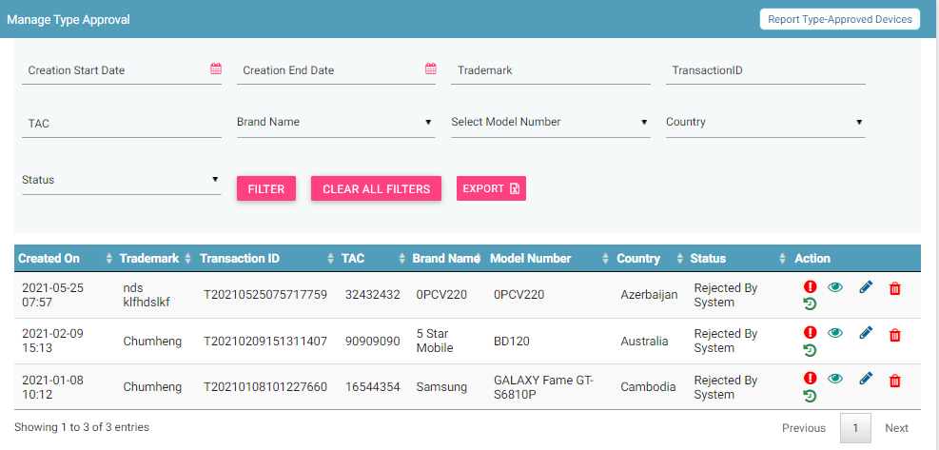

Figure 20: Manage Type-Approved

The following columns are seen on the page.

| **Column** | **Description** |
| --- | --- |
| Creation On | Date of adding type approval request. |
| Trademark | Trademark name |
| Product Name | Name of the device |
| Transaction ID | Transaction ID assigned to the request. |
| Model Number | Model number of the device. |
| Country | Country from where the device has been imported. |
| TAC | Type allocation code of the device. |
| Status | * New: This is the status assigned to the type approval request. * Processing: The request is processed internally. * Rejected by System: The request is rejected by the system if there is an error in the type approval request. * Approval Pending by CEIR Admin: After the processing is done, the type approval request sent for approval to the CEIR Admin. * Approved by CEIR Admin: The CEIR Admin approves the request. * Rejected by CEIR Admin: The CEIR Admin rejects the request. * Withdrawn by CEIR Admin: The CEIR Admin can withdraw the type approval request. * Withdrawn by User: The TRC can withdraw the type approval request. |
| Action | This displays different actions that can be performed on the type approval request.   * View A close up of a logo    Description automatically generated: This is used to view the type approval request. * Edit A close up of a logo    Description automatically generated: This is used to change the type approval request. * Delete : This is used to delete the type approval request. * History : This is used to view the transaction history of the request. |

## Edit Type Approved Devices

TRC s can modify the type approval request details.

To modify type approval request:

1. Click **Edit (A close up of a logo

   Description automatically generated)** against the entry to be modified.



Figure 21: Manage Type-Approved

The **Update Report Type-Approve Devices** page appears.

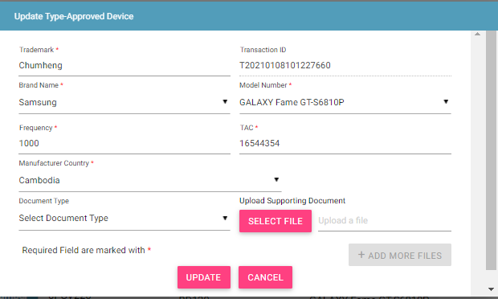

Figure 22: Update Report Type-Approve Devices

1. Make the required changes.
2. Click **UPDATE**.

## Filter Type Approval Requests

TRC can view specific type approval requests after defining specific values in the listed fields. For example, the TRC can view a device of a given TAC or a record if its transaction ID is known.

To view specific type approval requests:



Figure 23: Filter Type Approval Requests

1. Enter the required value in one or more of the listed fields:

* **Start Date and End Date**: This refers to the period of adding type requests in the system.
* **Transaction ID**: Each type approval request is assigned a unique transaction ID.
* **TAC**: This is the TAC assigned to the device.
* **Status**: Status of the type approval request.

1. Click **FILTER**.

The type approval requests that match the specified values are shown in the dashboard. 

**Figure 24: Filtered Type Approval Requests**

The user can clear all filters using the “**Clear All Filters**” button. This will reset all the filter values applied on the page and the data table will be refreshed.

## Sorting Type Approved Requests

By default, all records displayed are sorted based on modified date. User can sort the records by clicking the arrow button on header in the table displayed.

On first click, the records are sorted in ascending order. When user clicks the arrow buttons again, records are sorted in descending order.

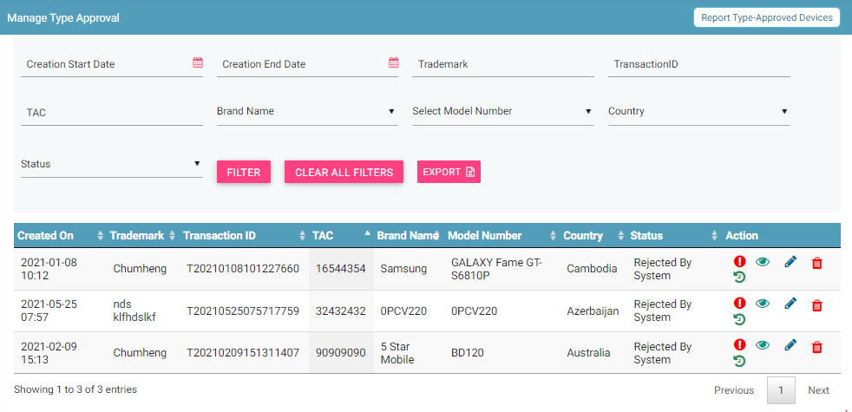

## Export Type Approved Requests

All the uploaded type approval requests can be downloaded in a **.csv** file. This is done using an export utility.

To export the type approval requests:

1. Click **Export** (seen on the top right corner of the **Manage Type-Approved** page).



Figure 25: Export Type Approval Requests

The following page appears.

Figure 26: Open or Save Exported File

1. Click **Open with** to view the file. The file opens as an Excel file.

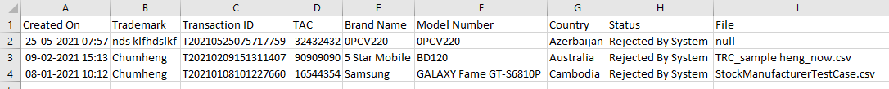

Figure 27: Exported Type Approval Requests

Users can export filtered data as well. To do this, filter the type approval requests and then export the filtered data. Refer to *Filter Type Approval Requests* for information and then export the filtered data

## Grievance Management

TRC can register complaints or grievances when there is a problem in the portal. For example, there could be situations when the registration feature is not working or there could be a problem in reporting the type approval request.

When a TRC raises a grievance, the grievance goes through the following stages:

1. A notification is sent to the CEIR Admin. The notification appears on the CEIR Admin portal. A mail is also sent to the registered mail of the CEIR Admin.
2. The CEIR Admin responds to the grievance. A response notification is sent to on the TRC portal, and the TRC ’s registered mail ID.
3. Steps 1 to 2 are repeated until the grievance is closed. The CEIR Admin closes the grievance.

There are situations when the grievance is automatically closed. A grievance is automatically closed when the status of the grievance changes to **Pending with User**, but there is no response from the TRC for a specified period.

To raise a grievance

1. Select **Grievance Management** in the left panel.

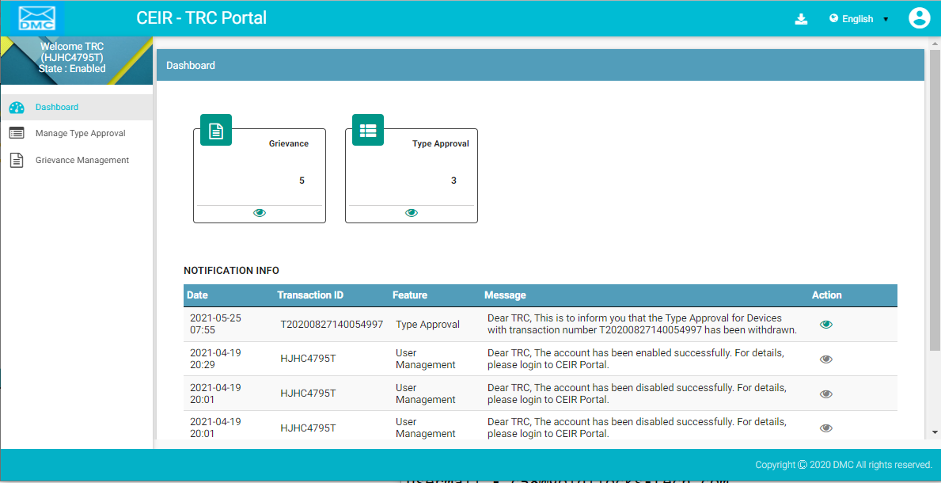

Figure 28: Home Page

1. The **Grievance Management** page appears. Click **Create Grievance**.

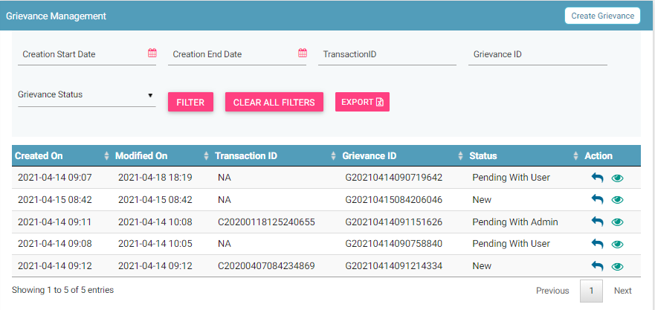

Figure 29: Grievance Management

The **Create Grievance** page appears.

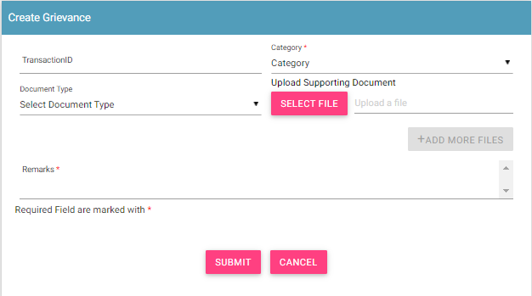

Figure 30: Create Grievance

1. Enter the following information:
   1. **Transaction ID**: Enter the transaction ID of the type approval request if the grievance is related to a type approval request
   2. **\*Category**: Select the category of the grievance. The options are:

* Type Approval Related: Problem in reporting type approval request etc.
* Other: Problem with any other aspect of the application
* Registration Related: Problem with registering information in the application.
  1. **\*Remarks:** Enter information about the grievance raised. This helps the CEIR Admin to understand the problem in detail.
  2. **Document Type:** Select the type of identification or another document that is to be uploaded. The options are:
* Passport
* Technical Specification Document
* Performance Report
* Type Approved Certificate
* Visa
* NID (National ID)
* Photo
* Other
  1. **Upload Supporting Document:** Click **Select File** to upload the document selected in **Document Type**.
  2. To upload more documents,click **+Add More Files.**

This adds two more fields: **Document Type** and **Upload Supporting Document**.

1. Click **SUBMIT**.

A grievance ID is generated and assigned to the registered grievance. The registered grievance appears on top of the dashboard.



Figure 31: Grievance Management

For each grievance added, the following information is displayed on the page.

| **Column** | **Description** |
| --- | --- |
| Raised Date | Date of raising a grievance. |
| Last Update Date | The date when the grievance was modified. |
| Transaction ID | The transaction ID of type approval request for which a grievance was raised. |
| Grievance ID | This is the ID that is automatically assigned to the grievance. |
| Grievance Status | The uploaded grievance goes through different status modes.   * New: When a grievance is raised. * Pending with CEIR Admin: When a response is awaited from the CEIR Admin. * Pending with User: When a response is awaited from the TRC . * Closed: When the CEIR Admin closes the grievance. |
| Action | This displays different actions that can be performed on a grievance.   * Reply : This is used to respond to the grievance. The response is provided by the CEIR Admin or TRC. The exchange of responses is done until the grievance is closed. * View A close up of a logo    Description automatically generated: This is used to view the grievance response history. The TRC can see all the responses exchanged for any grievance. |

## Filter Grievances

The TRC can view selective grievances depending on specific filter values. For example, the TRC can view only those grievances that are pending with the CEIR Admin. Similarly, one can view only those grievances that are closed.

To filter grievances:



Figure 32: Filter Grievances

1. Specify the required value in one or more of the fields listed:

* **Start Date** and **End Date**: Period of raising grievances.
* **Transaction ID**: This is the transaction ID of the type approval request.
* **Grievance ID**: This is the ID assigned to the grievance.
* **Grievance Status**: The status can be:
  + New
  + Pending with CEIR Admin
  + Pending with User
  + Closed

1. Click **Filter**.

The filtered grievances are shown on the page.

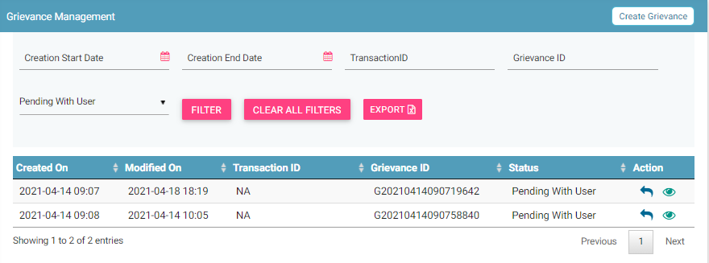

Figure 33: Filtered Grievances

The user can clear all filters using the “**Clear All Filters**” button. This will reset all the filter values applied on the page and the data table will be refreshed.

## Sorting Grievances

By default, all records displayed are sorted based on modified date. User can sort the records by clicking the arrow button on header in the table displayed.

On first click, the records are sorted in ascending order. When user clicks the arrow buttons again, records are sorted in descending order.

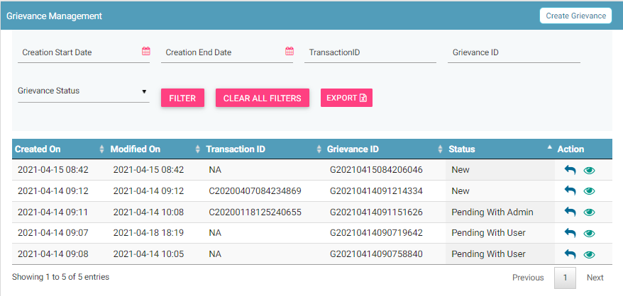

Figure 34: Sorted Grievances

## Export Grievances

All the uploaded grievances can be downloaded in a **.csv** file. This is done using an export utility.

To export the grievances:

1. Click **Export** (seen on the top right corner of the **Grievance Management** page).

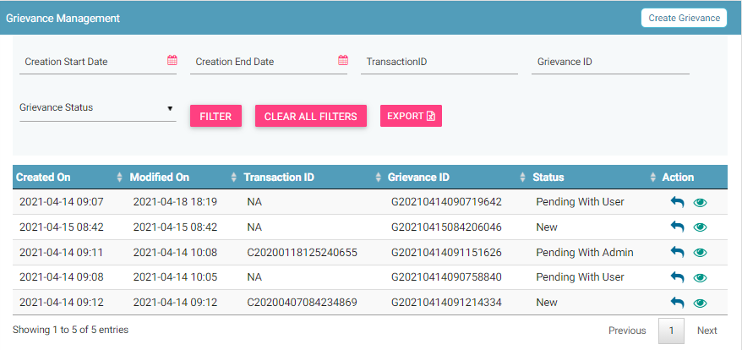

Figure 35: Grievance Management

The following page appears.

Figure 36: Open or Save Exported Grievance File

1. Click **Open with** to view the file.

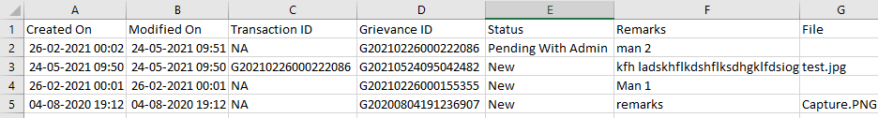

Figure 37: Exported Grievances

Instead of exporting all the grievances, TRC s can export filtered grievances. First, filter the grievance data based on specific filters (refer to *Filter Grievances*) and then export the filtered grievances using the export utility.